Trade of Sheet Metalwork
Module 3: | Thermal Processes
Unit 15: | TAG Welding Open Corner Joint – Flat Position
 | Phase 2

Table of Contents
List of Figures 5
List of Tables 5
Document Release History 6
Module 3 – Thermal Processes 7
Unit 15 – TAG Welding Open Corner Joint – Flat Position 7
Learning Outcome: 7
Key Learning Points: 7
Training Resources: 7
Key Learning Points Code: 7
Assembly of Equipment 9
Slope-in (Slope-up) 10
Slope-out (Slope-down) 10
Gas Regulator, Flowmeter and Economiser 11
TIG Welding Process 12
Tungsten-Arc Gas Shielding Welding 13
Flat Position 13
Corner Joint 13
Heat and Temperature 14
Heat Transfer 15
Conduction 15
Conductor and Insulators of Heat 16
Convection 16
Radiation 17
Expansion and Contraction 19
The Bimetal Strip 20
Thermostats 20
Linear Expansion 22
Specific Heat Capacity 24
Example 1 24
Example 2 25
Change of State (Latent Heat) 27
Arc Welding Processes 29
Terms Commonly used in Gas Shielded Welding 30
Self Assessment 31
Answers to Questions 1-4. Module 3.Unit 15 33
Index 35

List of Figures
Figure 1 - TAGS Welding 8
Figure 2 - A.C. Power Source 9
Figure 3 - D.C. Power Source 9
Figure 4 - Argon Flowmeter 11
Figure 5 - TIG Welding Process 12
Figure 6 - Temperature Scale 14
Figure 7 - Conduction 15
Figure 8 - Rate of Heat Transfer Experiment 15
Figure 9 - Conductor and Insulators of Heat 16
Figure 10 – Convection 16
Figure 11 – Radiation 17
Figure 12 – Black and Bright Surfaces 17
Figure 13 - Expansion and Contraction 1 19
Figure 14 - Expansion and Contraction 2 19
Figure 15 - Bimetal Strip 20
Figure 16 - Linear Expansion 22
Figure 17 - Change of State 27
Figure 18 - Arc Welding Processes 29

List of Tables
Table 1 - Specific Heat Capacities Values 25

Document Release History
Date | Version | Comments
12/10/06 | First draft
08/04/14 | 2.0 | SOLAS transfer

Module 3 – Thermal Processes

Unit 15 – TAG Welding Open Corner Joint – Flat Position
Duration – 4 Hours

Learning Outcome:
By the end of this unit each apprentice will be able to:
- Read and interpret drawing and weld symbols
- Operate and adjust TAGS welding plant
- Tack weld plates to form open corner joint
- Complete open corner tag weld in the flat position in 1.2 mm stainless steel

Key Learning Points:
Rk D | Weld symbol.
Rk | Power source – current setting – gas flow – after flow.
Rk | Ceramic shields – sizes and types.
M Sc | Effects of heat – expansion, contraction, thermal conductivity, co-efficient of linear expansion.
Rk | Purging of root.
Sk Rk | Tacking procedure.
Rk Sk | Welding technique – rod angle, torch angle.
Rk Sk | Distortion control – use of chills.
Rk | Safety precautions – skin and eye protection, first aid.

Training Resources:

- T.A.G.S. welding plant
- 1.2 mm stainless steel
- Toolkit
- Safety clothing
- Filler rods
- Figure 1
- Video

Key Learning Points Code:
M = Maths D= Drawing RK = Related Knowledge Sc = Science
P = Personal Skills Sk = Skill H = Hazards

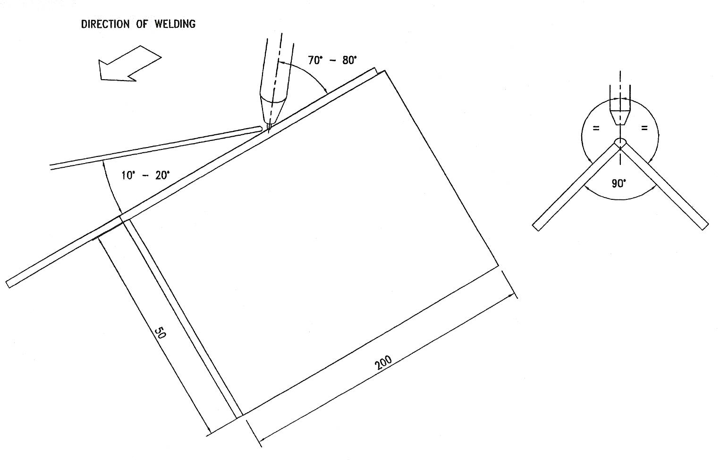
Figure 1 - TAGS Welding

Assembly of Equipment
The initial installation and connection of the power source to the main supply should be carried out by a competent person.
A.C. Power Source with separate auxiliaries.

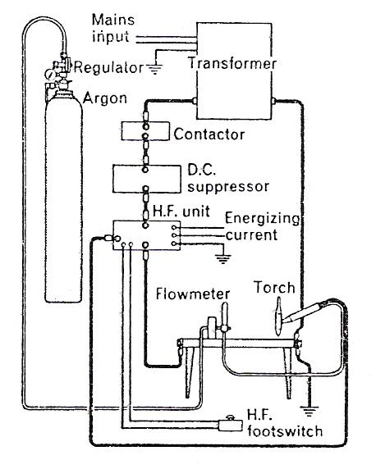
Figure 2 - A.C. Power Source

D.C. Power Source with separate auxiliaries.
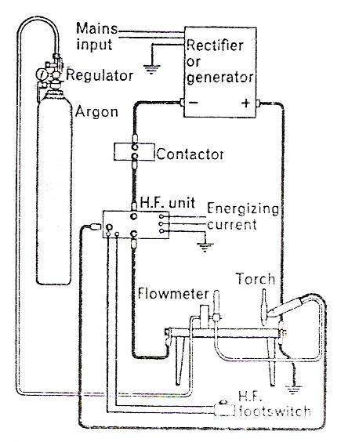
Figure 3 - D.C. Power Source

Slope-in (Slope-up)
When welding thinner sections, the use of the normal welding current at the beginning of the weld often causes burn-through. To prevent this a slope-in control is provided which gives a controlled rise of the current to its normal value over a preselected period of time which can be from 0 to 10 seconds. The soft start control is available on some equipment and performs the same function but it has a fixed time of operation and can be switched in or out as required.

Slope-out (Slope-down)
The crater which would normally form at a weld termination can be filled to the correct amount with the use of this control. The crater-filling device reduces the current from that used for the welding operation to the minimum that the equipment can supply in a series of steps. The slope-out control performs the same function, but the current is reduced over a period of 20 seconds as a linear function (not steps). The tendency to cracking is reduced by the use of this control.

Gas Regulator, Flowmeter and Economiser
The gas regulator reduces the pressure in the argon cylinder from 175 or 200 bar down to 0-3.5 bar for supply to the torch (Figure 4 a and b). The flowmeter, which has a manually operated needle valve, controls the argon flow from 0-600 litres/hour to 0-2100 litres/hour according to type (Figure 4 c).
The economiser may be fitted in a convenient position near the welder and when the torch is hung from the projecting lever on the unit, argon gas and (if fitted) water supplies are cut off. A micro-switch operated by the lever can also be used to control the HF unit.

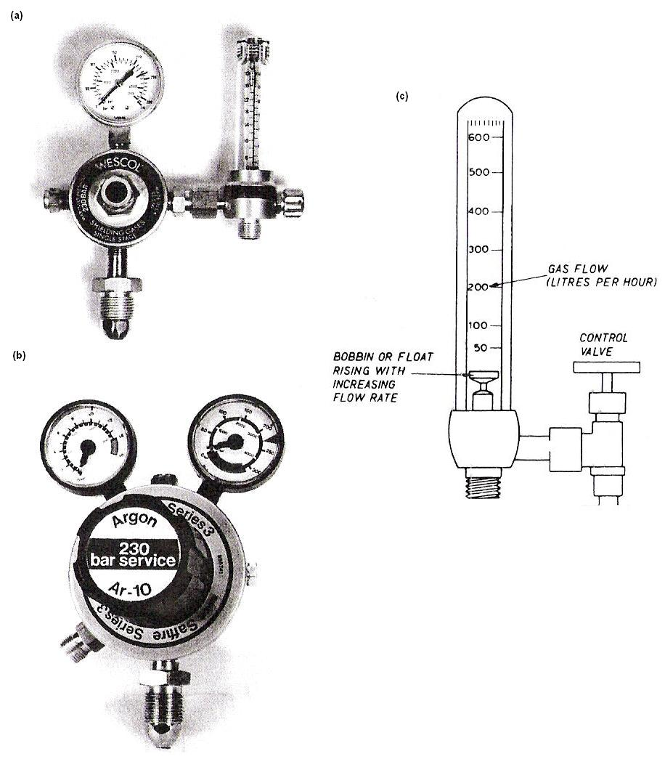
Figure 4 - Argon Flowmeter

TIG Welding Process
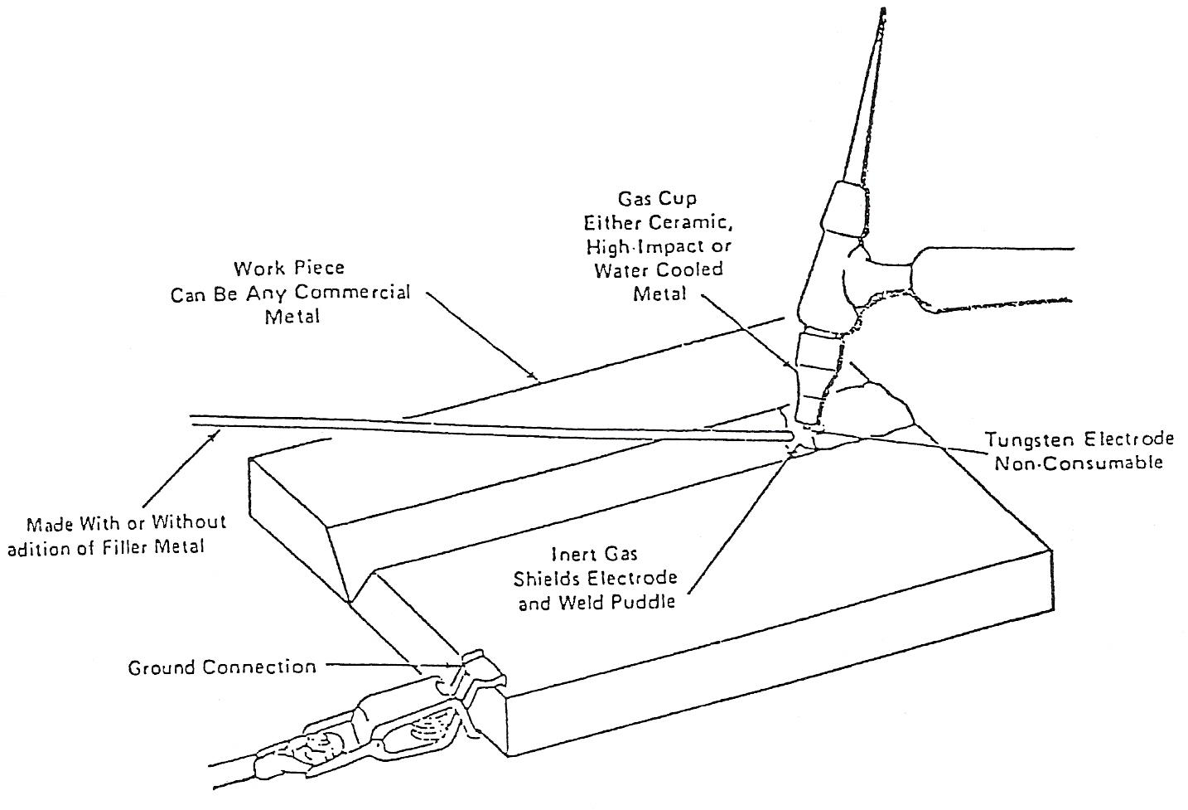
Figure 5 - TIG Welding Process

The necessary heat for gas tungsten-arc welding is produced by an electric arc maintained between a non-consumable electrode and the part to be welded. The heated weld zone, the molten metal, and the tungsten electrode are shielded from the atmosphere by a blanket of inert gas fed through the electrode holder. The TIG torch brings heat only to the workpiece. If filler metal is desired, it may be added manually like in oxy-acetylene welding or an automatic filler metal feeding system can be utilised. Figure 5 shows the essentials of the TIG welding process.
The TIG process has advantages over the other welding processes which in many cases make it more desirable to use. Some of these advantages are:
HIGHLY CONCENTRATED ARC:
This permits pinpoint control of heat allowing a narrow heat affected zone. A high concentration of heat is an advantage welding metals that possess high heat conductivity, such as aluminium and copper. Because of the highly concentrated are, some safety precautions should be observed:
- Unprotected skin is quickly "sunburned" by the arc rays.
Eyes should be properly protected by the correct shade of lens. Other workers in the area must be protected from stray glare or flash.
- When welding in confined areas, such as inside tanks or containers, concentrations of ozone and nitrous oxides can easily reach an unsafe level. Precautions must be taken to ventilate these areas properly.

Tungsten-Arc Gas Shielding Welding

Flat Position

Corner Joint
MATERIAL | 1/8˝ (3.0 mm) stainless steel, 2 off, min. 2˝·(50.0 mm) x 8" (20.0 cm)
PREPARATION | Square edge
ASSEMBLY | Tack weld with five tacks to give included angle of 90° without gap at the root
ELECTRODE | 3/32˝ (2.5 mm)
EXTENSION | 5/16 (5.0 mm) max.
ARGON | 8 - 12 ft.³/hr.
CURRENT | 110 – 125 amperes
FILLER | 3/32˝ (2.5 mm)

Example Procedure EP45

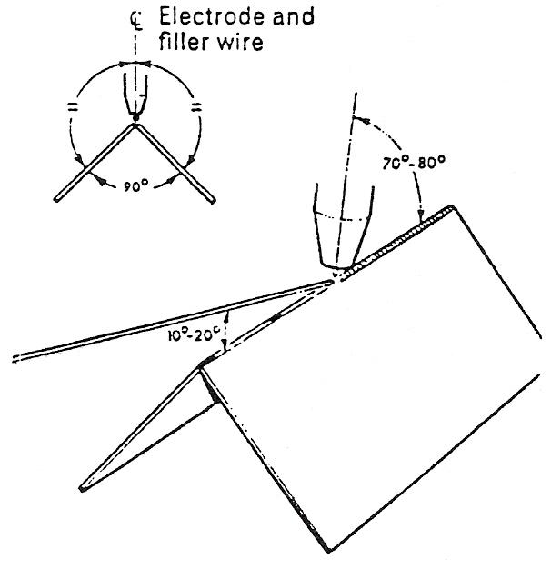
- Establish the arc on the tack weld at the right-hand end of the joint.
- As soon as small pool of molten metal is formed add filler metal.
- Point the electrode at the root of the joint at an angle of 70°-80°.
- Move the torch progressively leftwards, coordinated with the melting of filler metal to just fill the joint.
- Keep arc length short.
- Adjust rate of travel to avoid excessive melting away of the top edges of the fusion faces or excessive fusion through the root.
- When the tack weld at the left-hand end of the joint is reached, move the torch so that the electrode is perpendicular.
- After fusing the tack weld and building up the weld section, break the arc in the correct manner.

Visual Examination
With correct speed of travel a full weld with a slightly convex profile will result. The underside of the joint should show fusion to the root or even a slight penetration bead.

Heat and Temperature
Heat is a form of energy. There are numerous every day actions where mechanical energy is converted to heat energy, e.g. rubbing one's hands together, sharpening a centre punch on a grindstone, applying a brake to a moving vehicle, etc. In each case the mechanical energy expended reappears in the form of heat energy. When heat energy is added to a body it can usually be sensed by the "hotness" of the body. The degree of "hotness" of a body is known as the temperature of the body. A thermometer is used to measure temperature and it is calibrated in degrees Celsius.
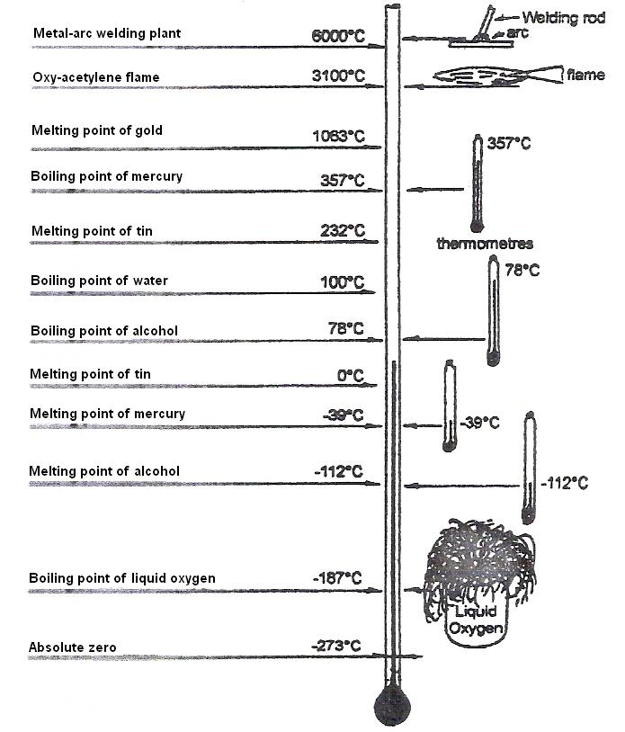
Figure 6 - Temperature Scale

Test Yourself:
Refer to the temperature scale above:
- State the melting and boiling points of mercury.
- State the melting and boiling points of alcohol.
- State the most suitable liquid, mercury or alcohol for a thermometer is to be used:
- in a cold room,
- to measure the temperature of steam in the 140°C region.

Answers:

- melting point 39°C, boiling point 357°C
- melting point 112°C, boiling point 78°C
- (i) alcohol,
(ii) mercury

Heat Transfer
Heat may be transferred from a hot body to a cooler body in one or more of the following ways:
  - by Conduction,
  - by Convection,
  - by Radiation.

Conduction
Heat can travel through solids. When a short piece of a metal rod is heated in a flame, it rapidly gets too hot to hold. Heat has been transferred by conduction through the metal from the flame to the hand. When the metal rod is secure in a wooden handle gripped in the hand they can now be held comfortably. Wood is a poor conductor of heat while metal is a good conductor of heat.
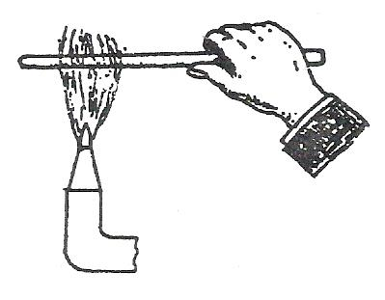
Figure 7 - Conduction

The rate of heat transferred through four common metals, copper, aluminium, steel and cast iron may be demonstrated by the simple experiment as shown in Figure 8.
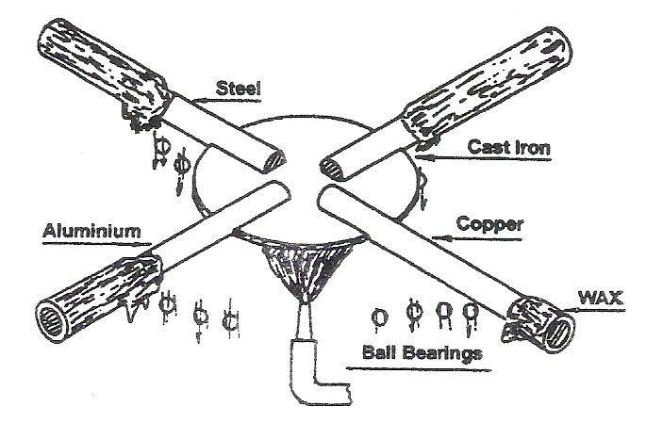
Figure 8 - Rate of Heat Transfer Experiment

When the heat is applied to the centre, the ball bearing supported by the wax attached to the copper will fall first, followed by a ball bearing from aluminium then steel and finally the cast iron.

Conductor and Insulators of Heat
Generally speaking, metals are good conductors of heat and non-metals are poor heat conductors. A poor heat conductor is known as an insulator. Most liquids are poor conductors of heat.
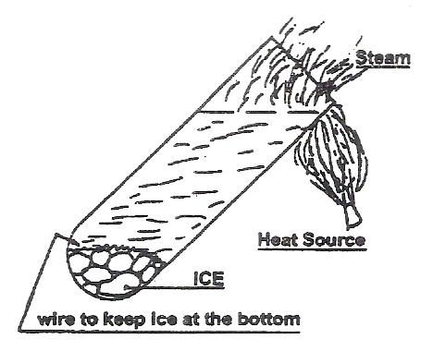
Figure 9 - Conductor and Insulators of Heat

The sketch shows a simple experiment which shows that water is a poor conductor of heat. The water at the top of the test tube is heated. Even when the water at the top is boiling the ice at the bottom is not melting indicating that water is a poor conductor of heat.

Convection
Water is a very poor conductor of heat; however when water is boiled in an electric kettle the heating element only warms the water next to it. The heated particles rise up bringing heat with them. This is known as heat transfer by convection. Convection means that heat is carried through liquids and gases by movement of particles.
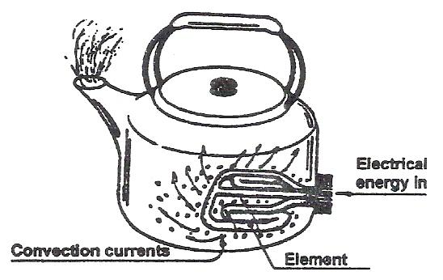
Figure 10 – Convection

Radiation
The heat that reaches us from the sun travels by radiation. Radiated heat can travel through a vacuum unlike heat transferred by conduction or convection. It travels according to the laws of light and it is reflected and absorbed in the same manner.
A simple experiment may be used to show that dark surfaces absorb heat better than bright surfaces. Two coins are attached to both surfaces as shown below. The coin attached to the dark surface falls first showing that a dark surface is better absorber of heat than a bright surface. Bright surfaces reflect heat in a similar manner to the reflection of light.
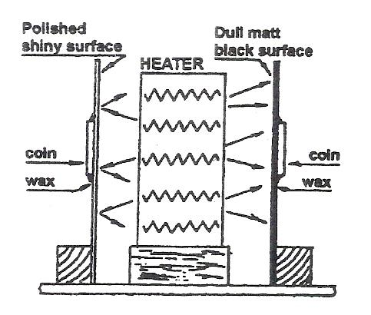
Figure 11 – Radiation

A similar type of experiment may be used to demonstrate that black surfaces are also better radiators of heat than bright surfaces.
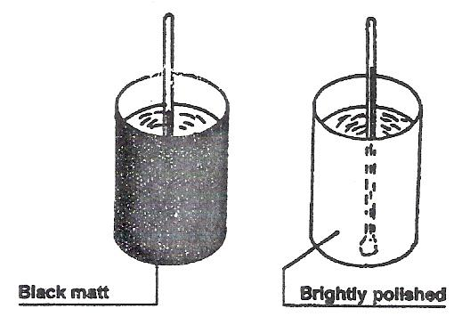
Figure 12 – Black and Bright Surfaces

The sketch shows two similar cans filled with hot water, one can has its surface painted black while the surface of the other can is brightly polished. It may be observed that the temperature falls faster in the black painted can than the brightly polished can.
DARK SURFACES are better at absorbing and radiating heat than bright surfaces.
Test Yourself
- List the following metals in order of their heat conductivity, placing copper first:-
Copper, tin, lead, steel, cast iron and aluminium.
- List four heat insulators.
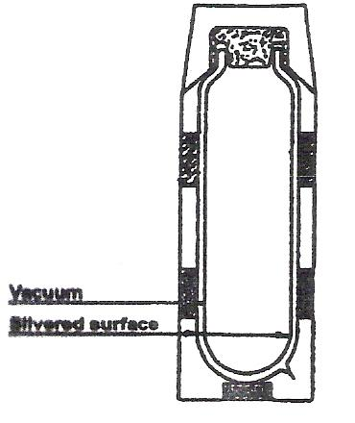
- The sketch shows a Thermos flask. State the characteristics in the design of the Thermos flask which reduces heat loss by:-
- Conduction,
- Convection,
  - Radiation.

Answer:
- 1 - copper, 2 - aluminium, 3 - steel, 4 - tin, 5 - cast iron, 6 - lead.
- Wood, rubber, cork and glass.
- (i) Heat loss due to conduction is reduced by glass container, plastic top and vacuum.
(ii) Heat loss due to convection is reduced by vacuum.
(iii) Heat loss due to radiation is reduced by silvered surfaces.

Expansion and Contraction
Most materials commonly met with, within engineering increase in size as their temperature increases and contract again when cooled. The expansion of a material due to heating can be both an advantage and disadvantage.
The ends of a long length of railway track are allowed to overlap with the next length of track. This allows the rails to expand and contract with atmospheric changes while at the same time allowing the train to move smoothly along the track.

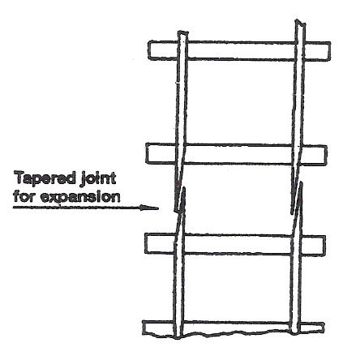
Figure 13 - Expansion and Contraction 1

When fitting a bearing to a shaft the shaft may be cooled or the bearing heated in oil prior to assembly. When the bearing/shaft reaches the same temperature an interference fit exists between the shaft and the bearing, thus preventing movement of the inner bearing ring on the shaft under load.

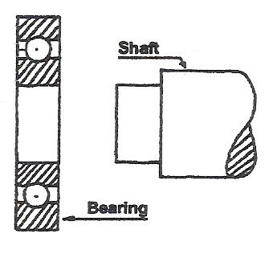
Figure 14 - Expansion and Contraction 2

The Bimetal Strip
Different metals expand by different amounts when they are heated. One application of this characteristic is the bimetal strip.
When the bimetal strip is heated the copper expands by a greater amount than the steel. This makes the strip bend with the copper on the outside because the distance around the outside of the curve is greater than the distance around the inside curve. If the bimetal strip was cooled it would bend in the opposite direction.
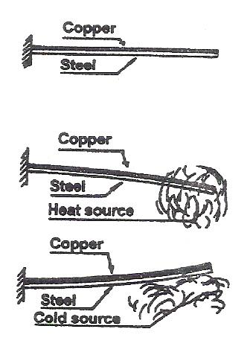
Figure 15 - Bimetal Strip

Thermostats
Thermostats are fitted to room heaters, oil fired boilers, refrigerators, cooker etc. to maintain the temperature steady. Most thermostats use a bimetal strip to open or close an electric contact. In an electric room heater, when the temperature reaches a preset value the bimetal strip bends and a contact opens, cutting off the electricity supply to the heater. When the room temperature falls the bimetal strip closes the contact and the heater is again switched on.
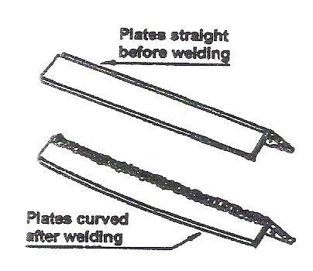
The figure below shows a simple type of fire alarm. When the bimetal strip is heated it bends downwards, closing the electric contact which sets off the fire bell.
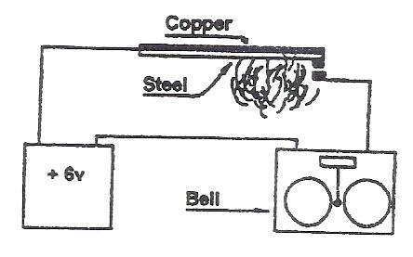

In welding, expansion due to the concentration of heat at a point may lead to distortion of the final workpiece. The sketch shows two plates welded together to form a 90° angle. When the plates cool we find that they are curved in the direction of the weld.

Test Yourself
- What is the principle on which the mercury thermometer is based?
- Why are loops, as shown below, sometimes formed on hot water pipes?
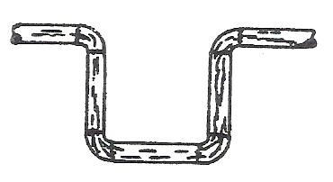
- Draw a simple diagram to show a bimetal strip used to control the temperature of a refrigerator.
N.B. Thermostat contact must be open on cooling.

Answers

- The mercury thermometer is based on the principle that mercury expands when heated.
- These loops provide for expansion and contraction of a long pipe run when the hot water temperature changes.
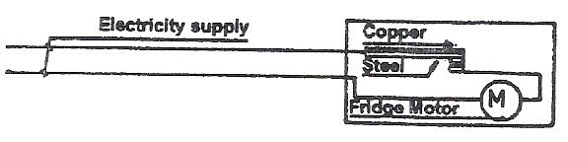

Linear Expansion
If a bar of steel is heated uniformly in a furnace it will expand naturally in all directions if it is not restrained in any way. If allowed to cool evenly and without restraint it contracts to its original shape and size without distortion, as shown in illustration below.
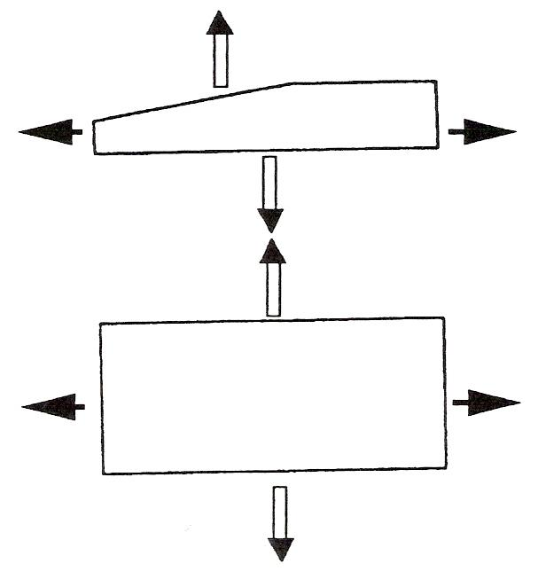
Figure 16 - Linear Expansion

If the original dimensions, the rise in temperature, and the expansion of the metal block (Figure 16) are measured, it will be found that they are related to each other. Thus, for a given metal:
  - The expansion is proportional to the rise in temperature.
  - The expansion is proportional to the original size of the component.

Expressed mathematically this gives the formula:

x = l α t

Where:

x = increase in size
l = original length
α = coefficient of linear expansion
t = rise in temperature
The table below gives the values of α for some common engineering materials (α is the Greek letter 'alpha').
Expansion in long straight runs of pipeline can cause problems, as the following example will illustrate:
EXAMPLE: A straight length of copper pipeline measures 30 metres at room temperature (15°C). After hot water has been passing through it for some considerable time, its temperature is raised to 60°C. Calculate its increase in length.

Material | Coefficient of linear expansion
Lead | 0·000 | 028/°C
Aluminium | 0·000 | 023/°C
Brass | 0·000 | 02/°C
Copper | 0·000 | 017/°C
Mild steel | 0·000 | 011/°C
Wrought iron | 0·000 | 011/°C

Solution: x = l α t
= 30 x 0.000 017 x (60-15)
= 30 x 0.000 017 x 45
Increased length = 0.022 95 metres = 22.95 mm

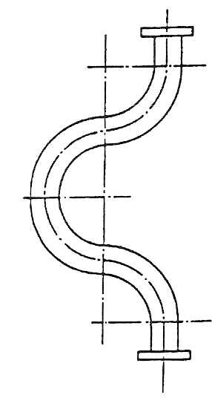

An increase in length of 23 mm is quite substantial; therefore pipelines for carrying steam or hot liquids require special provisions to compensate for expansion. The illustration here shows typical examples of expansion bends which can be introduced into pipeline systems.

Specific Heat Capacity
Different substances absorb different amounts of heat to raise the temperature of the substance by one degree. The quantity of heat required to raise the temperature of 1kg of a substance by 1°C is termed the “specific heat capacity” of the substance.

For instance 4,190J of heat energy is required to raise the temperature of 1kg of water through 1°C.

N.B. 1 litre of water has a mass of 1kg.

Specific heat capacity of water = 4190J.
It follows that if the temperature of 1kg of water is to be raised by 20°C.
Total heat required = 4190 x 20 = 83800J
Total Heat = mass x specific heat capacity x temperature rise

Example 1
Calculate the quantity of heat required to raise the temperature of 3 litres (3kg) of water from 10°C to 100°C.

Increase in temperature = 100 – 10 = 90°C
Heat required = mass x specific heat capacity x temperature rise
= 3 x 4190 x 90
= 1,131,300J
= 1.13MJ

The following symbols are used for mass, specific heat capacity and temperature rise.

Mass, symbol m
Specific heat capacity, symbol c
Temperature rise, symbol t°

Heat Required = m c t°
The following are some typical values of specific heat capacities:

Substance | Specific Heat Capacity
Water | 4190 J / Kg / °C
Ice | 2100 J / Kg / °C
Iron | 500 J / Kg / °C
Brass | 370 J / Kg / °C
Copper | 390 J / Kg / °C
Aluminium | 950 J / Kg / °C
Table 1 - Specific Heat Capacities Values

N.B. the symbol J/Kg/°C means joule per kilogram per degree Celsius rise or fall in temperature.

Example 2
Calculate the heat required to raise the temperature of 5kg of copper from 15°C to 145°C.

Temperature rise = 145 – 15 = 130°C
(from table)
specific heat capacity = 390 J/Kg/°C

Heat Required = m c t°
= 5 x 390 x 130
= 253,500
= 253.5KJ

Test Yourself
    - Which of the following substances has the least specific heat capacity?
Iron, Brass, Copper or Aluminium.
    - 4Kg of copper at 100°C is placed in 4kg of water at 10°C would you expect the final temperature to be?
(i) 55°C, (ii) 80°C, (iii) 18°C (iv) 30°C.
    - The sketch shows the removal of a rim from a wheel. The rim is heated while the wheel is kept cool by a block of metal. Which metal, iron, brass, copper or aluminium is the most suitable?
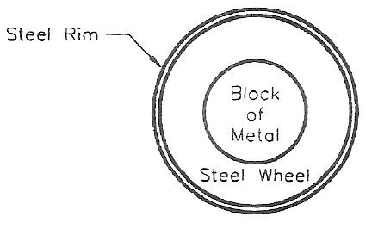

Answer:
  - BRASS, See Table 1 on the previous page.
  - 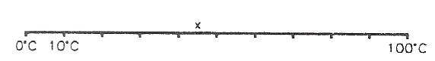
Let x°C be equal to the final temperature
Heat lost by copper = heat gained by water
4 x 390 (100 - x) = 4 x 4,190 (x - 10)
1,560 (100 - x) = 16,760 (x - 10)
156,000 - 1,560x = 16,760x - 167,600
323,600 = 18,320x
17.66°C = x
  - Aluminium, since it has the greatest specific heat capacity.

Change of State (Latent Heat)
When ice at -20°C is heated it absorbs heat and its temperature rises gradually until it reaches 0°C. The temperature of the water/ice mixture remains at 0°C until all the ice is melted. The effect of the heat supplied to melt the ice does not show up on a thermometer and hence appears as hidden or latent heat.
When all the ice is melted, further addition of heat increases the water temperature and it eventually reaches 100°C. The temperature remains at 100°C until all the water has changed into steam at 100°C. This again is hidden or latent heat.

Latent heat is heat taken in or given out when a substance is changing state without changing temperature.

The sketches and graph below show the change in temperature against time, when a constant heat source is used to convert ice at -20°C into steam at 100°C.
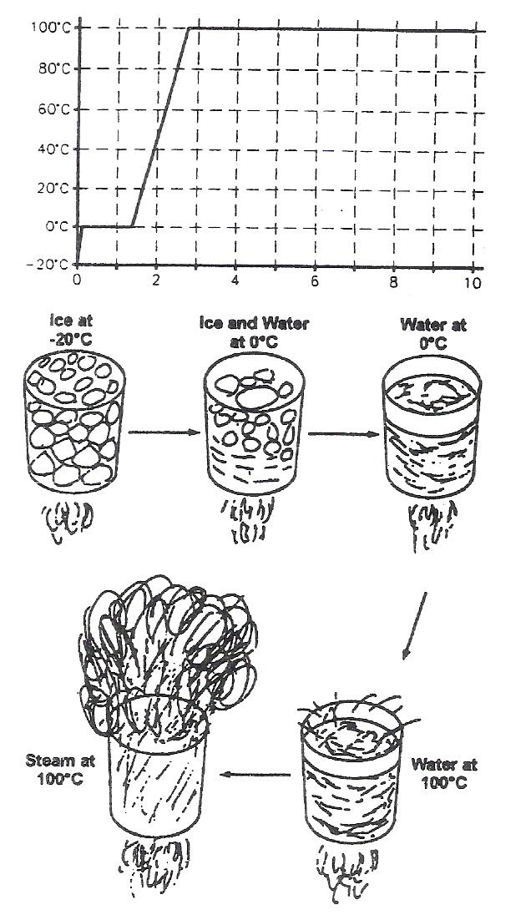
Figure 17 - Change of State
The heat required to change 1kg of a substance from the solid state into the liquid state is known as the specific latent heat of fusion of the substance. The specific latent heat of fusion of ice is 335 kJ/Kg.
The heat required to change 1kg of a substance from the liquid state into the vapour state is known as specific latent heat of vaporisation of that substance. The specific latent heat of vaporisation of water is 2,257 kJ/Kg.

Test Yourself
- Explain, briefly, which would cause the worst burn:- Boiling water or steam.
- Assuming a kettle takes 1 minute to raise the temperature of a quantity of water from 0°C to 100°C, approximately how much time would be needed for all the water in the kettle to evaporate. (HINT: refer to the graph in Figure 17).

Answer:
- Steam would cause the more severe burn. Steam contains more heat than boiling water.
- It would take about five minutes. The graph on the previous page shows that it takes about five times as much energy to evaporate the water as to raise its temperature from 0°C to 100°C.

Arc Welding Processes
Fabrications involving sheet metal, plate or pipes are commonly welded by an arc process.
Two of the most important processes use a gas shield to protect the weld metal from atmospheric contamination.

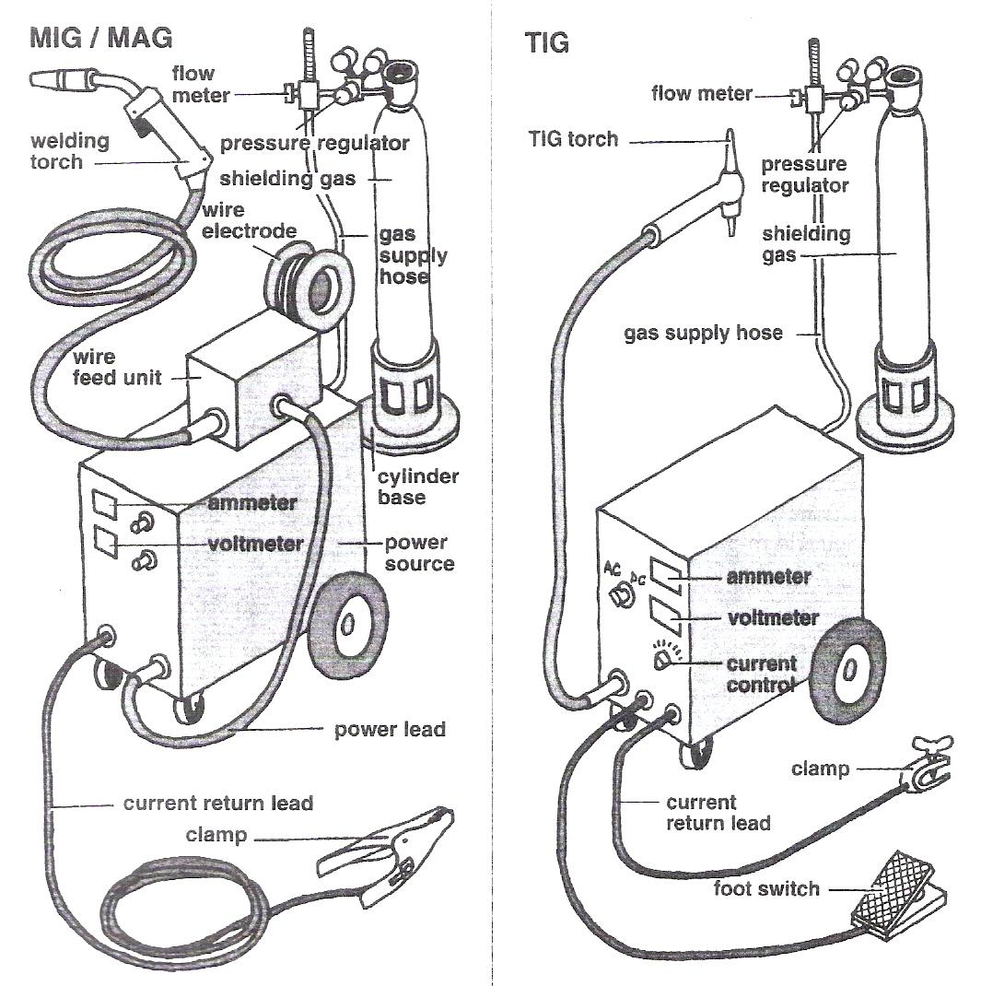
Figure 18 - Arc Welding Processes

Terms Commonly used in Gas Shielded Welding
arc length Distance between the tip of the electrode and the surface of the weld pool.
base metal Incorrectly used to describe the metal from which the components of the joint are made. The correct term is parent metal.
bead A single run of weld metal deposited onto the surface of the parent metal.
burn-off rate The rate at which the wire is melted. Quoted as a linear measurement - m/min (metres per minute) or in/min.
deposited metal Material which is added, either from the electrode or filler wire, to build up the weld profile.
deposition rate The rate at which melted electrode metal is added to the weld pool. Quoted in kg/hr (kilograms per hour). Sometimes incorrectly used in reference to the ratio of metal deposited to the amount of electrode melted - this is the deposition efficiency.
electrode The flux coated rod in manual metal arc welding, the tungsten in TIG and plasma welding and the consumable wire in MIG/MAG welding. The arc is formed between the parent metal and one end of the electrode.
filler metal Metal added to the weld pool during welding. For TIG it is supplied as cut lengths of wire.
interpass The temperature of the material adjacent to the joint between
temperature each run is the interpass temperature. In some applications, a maximum temperature is specified to avoid metallurgical changes in the metal.
melt run Melting the parent metal by passing a TIG arc along the surface. Filler metal is not used.
nozzle In TIG and MIG/MAG welding - a metal or ceramic tube which confines the shielding gas to the weld area.
parent metal The metal which is to be joined by welding. Often incorrectly called the base metal.
pass or run The metal deposited during one traverse of the joint by an arc. In TIG welding without a filler, the term melt run may be more correct.
preheat The temperature of the parent metal just before welding is started.
temperature With some metals the parent metal is heated before welding to avoid problems such as cracking or lack of fusion.
root run The first run deposited in a joint where further runs are needed to fill the groove.
sealing run A run of weld metal deposited on the reverse side of a butt joint, along the line of the root.

Self Assessment

Questions on Background Notes – Module 3.Unit 15

1. What time span is involved when using the slope-in and or slope-out facility?

2. What should the current setting be for 3mm stainless steel?

3. What edge preparation is necessary to complete a corner weld/joint in the flat
position?

4. What is the danger to the welder and helper when welding in confined spaces?

Answers to Questions 1-4. Module 3.Unit 15

1.

From 0 to 10 seconds using slope-in depending on the thickness
of metal.

Slope-out facility may take 20 seconds as a linear function.

2.

110 – 125 amp is recommended for 3mm stainless steel.

3.

Proper Alignment. Both sides bevelled to 45° approx.

4.

Concentrations of ozone and nitrous oxides can easily reach an
unsafe level. Precautions must be taken to ventilate these areas
properly.

Index

A
Arc Welding Processes, 32
Assembly of Equipment, 9
C
Change of State (Latent Heat), 30
F
Flat Position
Corner Joint, 13
G
Gas Regulator, Flowmeter and Economiser, 11
H
Heat and Temperature, 15
Heat Transfer, 16
Conduction, 16
Conductor and Insulators of Heat, 17
Convection, 17
Expansion and Contraction, 21
Radiation, 19
L
Linear Expansion, 25
S
Self Assessment, 34
Slope-in (Slope-up), 10
Slope-out (Slope-down), 10
Specific Heat Capacity, 27
Example 1, 27
Example 2, 28
T
Terms Commonly used in Gas Shielded Welding, 33
The Bimetal Strip, 23
Thermostats, 23
TIG Welding Process, 12
Tungsten-Arc Gas Shielding Welding, 13
Flat Position, 13

